Tools - SMD Level Checks

Foundation | Person and population outcomes | Service outcomes | System outcomes
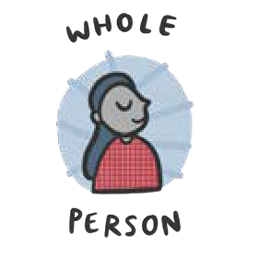 | - Greater stability, dignity and control across all aspects of a person’s life. | - Support responds to whole-life needs, not single-issues. | - Policy, funding and planning designed around whole-person outcomes.
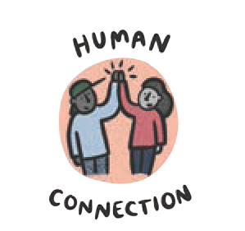 | - Stronger, trusting relationships and less need to retell their story. | - Continuity of support and  named coordination in place. | - Relational, trauma-informed practice becomes normal across partners.
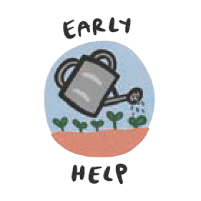 | - Fewer escalations into crises across all aspects of a person’s life. | - Reduced repeat crisis presentations. | - More resources focused earlier.  - Less pressure on acute and  emergency services.
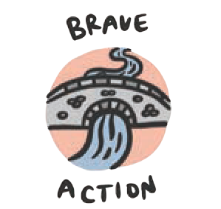 | - Faster, more coordinated support. | - Effective cross-sector coordination and safe data sharing. | - Feedback loops shape policy and resources.  - Reduced duplication and failure demand.

Your Heading
Foundation | Person and population outcomes | Service outcomes | System outcomes

