BACKGROUND

The Child Poverty (Scotland) Act 2017 sets stretching targets for child poverty reduction. There are two sets of targets – interim targets due in 2023-24 and final targets due in 2030-31.

As required by the Act, in March 2018 the Scottish Government published a ‘Tackling Child Poverty Delivery Plan’ for the period 2018-22. This set out policies and programmes to progress towards the targets including the Scottish Child Payment and the Parental Employability Support Fund.

Progress on actions in the delivery plan and an update of our current knowledge base is summarised in our annual progress reports.

The Plan identified six priority family groups where children are more likely to live in poverty. The figures below for these groups compare to 24% of all children who lived in relative poverty after housing costs (AHC) in the period 2017-20:

The Plan identified three key drivers of child poverty reduction and also included a strong focus on mitigating the impacts of poverty on children – helping to reduce child poverty in the longer term. The drivers of child poverty reduction are set out in the diagram below and demonstrate the wide ranging action required to support families:

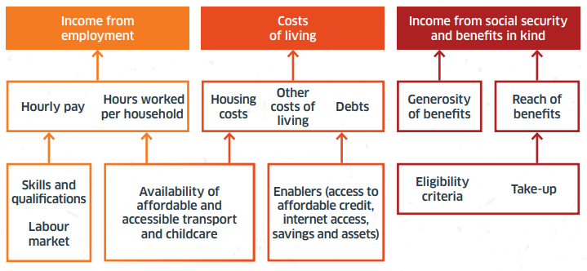

A second four-year plan is due in March 2022 for the period 2022-26. This plan is crucial if the 2023 targets are to be met and sufficient progress is to be delivered towards the 2030 targets.

Significant progress is required to get closer to the 2030 targets. The latest statistics cover up to March 2020, providing a picture of poverty pre-COVID

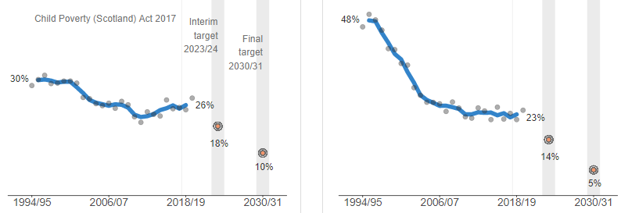
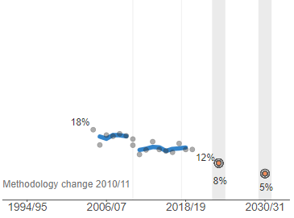
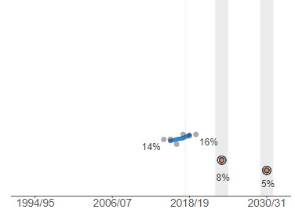
Relative poverty
Absolute poverty
Combined low income and material deprivation
Persistent poverty

